**Air Pollution Report Graphical Representation: by World Health Organization (May 2014)**

* How Much [Country wise air pollution by WHO]

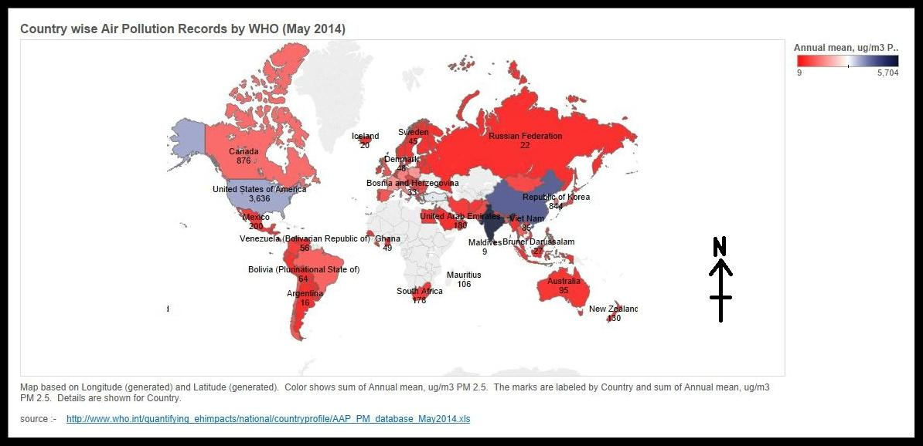

* How Many [Number of Records Per Region by WHO]

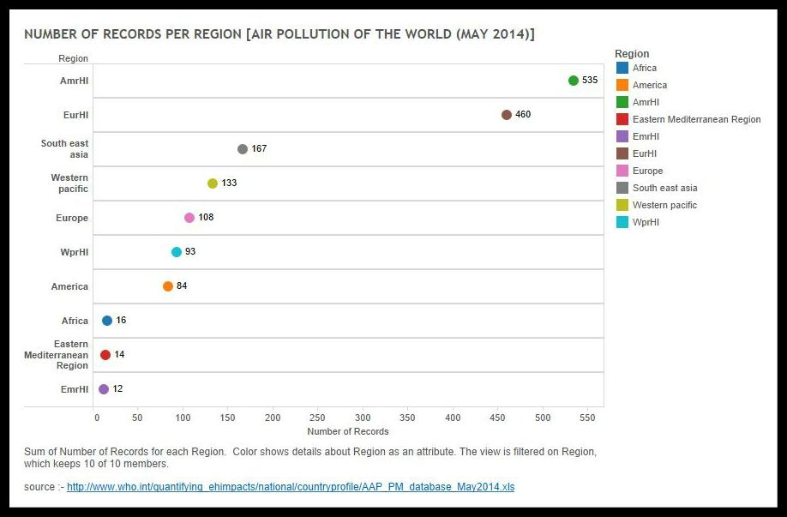

* Ratio [Region and Subregion Ranking by Pollution Ratio of (pm2.5/pm10)]

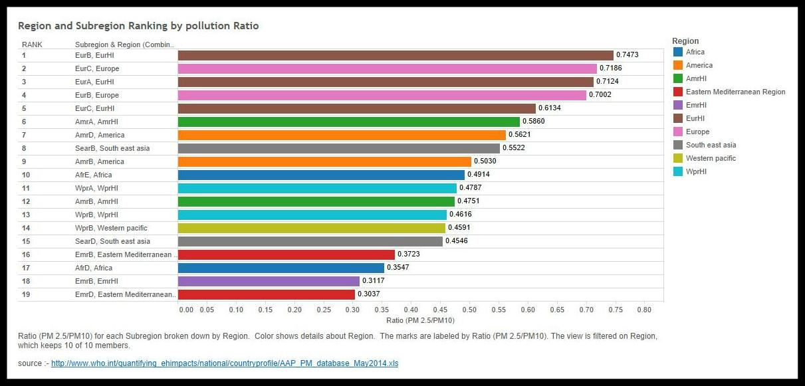

* Proportions [Ranking by pollution of per country]

